Claiming for Rights: The Changing Landscape of Issues and Claims in the National Petition of South Korea, 2017-2020.
Ka Yoon Kim, Chung-Ang University

Abstract
Introduction

Do social structure and factors affect people's claims? The purpose of this paper is to answer the question below, by revealing the impacts of society in claim-making through analyzing national e-petitions in South Korea. The question is important from a sociological perspective. Individuals can realize that they are connected to society experiencing personal problem publicized into social issues with consent. It is also meaningful for Korean society that through their claim-making, the past, present, and future of society appears. To be more specific, it contains inherent social, cultural, and political characteristics from the past. Those became the basis of the requests and issues that people are contending today. From the paper, it shows that most-popular categories and cosigned petitions are critical social problems to be changed immediately but the solutions for a better future simultaneously. Therefore, this study is crucial not only in Korean society but also in sociology in the way that it reflects the society from the contents of the petition also it represents the right direction that society should aim.

Literature Review
Previous studies have mainly considered the national petitions as means of the administrative system and political participation from a political perspective. A study suggests pros and cons of the petition system and contends how to improve it (Byeongrok Kim, 2019). Also, the petition data was used as a measurement to reveal the effects of emotion on political participation and judgment using natural language processing modules (Junmo Song & Youngdeuk Park, 2019). Also, text analysis and topic modeling on the posts of the national petition carried out (Hyesun Suh, Jinsoo So, 2020). Most studies in the subject of national petitions have only focused on itself from a superficial viewpoint. Therefore, this study is meaningful in that it aims to examine the national petition with sociological insight.

Theoretical Framework
Structuration theory (Anthony Giddens, 1984) asserts structure as recursively organized sets of rules and resources. On that basis, the social systems where the structure is implicated, comprise the activities of people. Also, human social activities are continually recreated by them via means whereby they express themselves. To sum up, while being influenced by the structure, an individual recognizes and changes it simultaneously. Based on the theory, the paper contends that social multi-perspective factors affect claim-making. Hence, it could be hypothesized that the content and subjects of the petition data will contain social aspects of the nation.

Data and Methods

The data used in this paper is the petitions appearing on the website (https://www1.president.go.kr/petitions) between Aug 17th, 2017 and Dec 31st, 2020 and the number of the data is 34809. Additionally, it includes the petitions whose total sum of signatures is equal to 100 or over. For the study, each petition was gathered in the database by concatenating precious archived data and using web crawling. To be elaborated in detail, data was collected by following steps. First, the database schema was created in MySQL which contains columns of time when a petition crawled, category, the date when a petition started and ended, title, content, the number of signatures, petition number(index), status whether closed or briefed by the administrative office. Next, considering the likelihood of deleting previous petitions on the website, archived data files (https://github.com/akngs/petitions, https://github.com/lovit/petitions_archive) added to the database before the web crawling. Third, by using the web crawler (https://github.com/lovit/petitions_scraper), the new data were saved in the database. Moreover, the function is used to connect between MySQL database and Python insert the data, and identify a duplication.

Based on big data, the quantitative method used in this paper. The specific method used to derive the result is as follows. First, for the comprehensive analysis, the proportion of each category visualized to a graph using the Matplotlib library of Python. Second, the ten most popular petitions were chosen by the number of signatures in detail. Finally, NLTK and Konlpy, which are natural language processing modules, were used to examine the keywords of petition contents for each category. After eliminating some words from stopwords, the most common 150 words were selected and visualized as Wordcloud. Finally, the study compared the contents and subjects of the petitions with “We the People” e-petition system run by the White House of the United States, which is the most similar to the petition platform format and political system.

Results
The results of this study suggest that the contents of petitions change by social factors. The grounds are as follows. To begin with, the category proportion graph by year shows that each category ratio increases or decreases differently every year. It suggests that the petitions have increased in response to specific triggered events each year. Besides, the analysis of 10 most popular petitions and the contents implies the appearance of Korean society. In detail, several social, political, and cultural factors inherent in the society can be found. The result implies that patriarchy and the mechanical solidarity remained in the social aspect. On the political side, it suggests the polarization and the distrust of lawmakers and a president. Petitioners also tend to treat the government as a single, unitary actor. Besides, part of authoritarianism from the past remained in the society. The hatred against certain groups was shown based on communitarianism. Finally, the petition analysis between the U.S. and Korea derives that certain differences in the contents and categories existed based on the socio-cultural differences of the country. Overall, these results imply that the research hypothesis is supported.

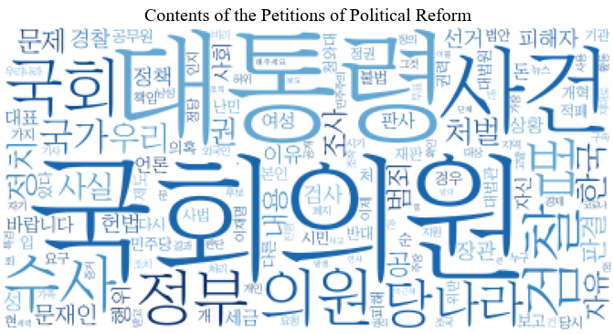 | 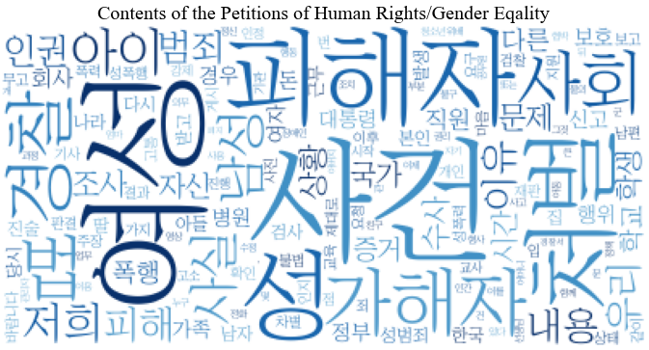
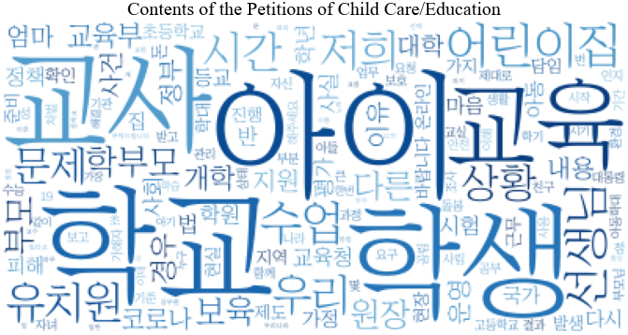 | 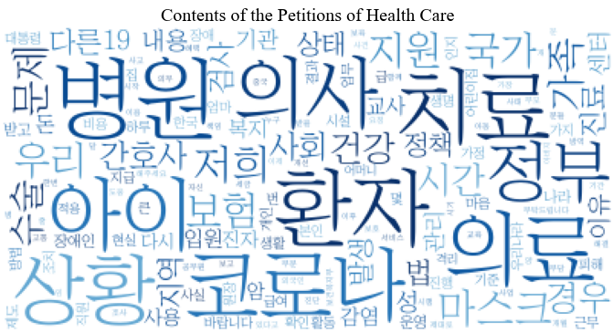
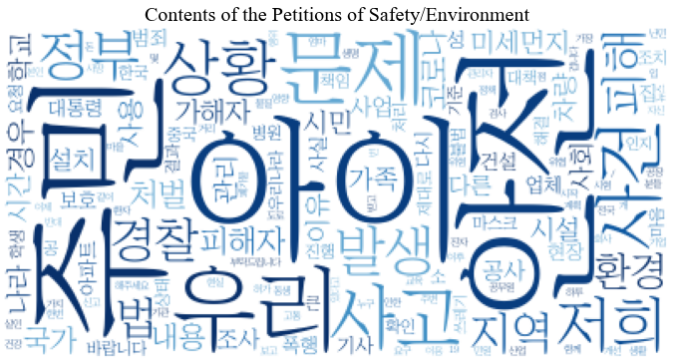

Conclusion
In conclusion, through the analysis of national petition big data, a strong relationship between political, social, and cultural factors disclosed in Korean society and claim-making of petitioners was reported in the paper. Also, the comparison with the White House petition in the United States proved that the contents and subjects of the petition change according to sociocultural factors internationally. It represents the current status of Korean society and finds the points that need to bring about change.

